Gerardo Berlanga Molina, Ruth Shiferaw, Thara Konduri

2.156 Mid-Project Progress Report

November 12, 2025

**Background/Motivation:** How do you pick the right camera lens for you? And more specifically, how do you know a lens design performs the way you want it to? Lens designs are a combination of individual lenses structured to maximize a specific performance (Fig 1). Not only is there no formula for creating a structure that matches a desired performance, but lens designs are expensive to manufacture and inefficient to individually simulate. It would be nice to, given certain desired parameters, be able to generate lens designs that meet these parameters and perform well.

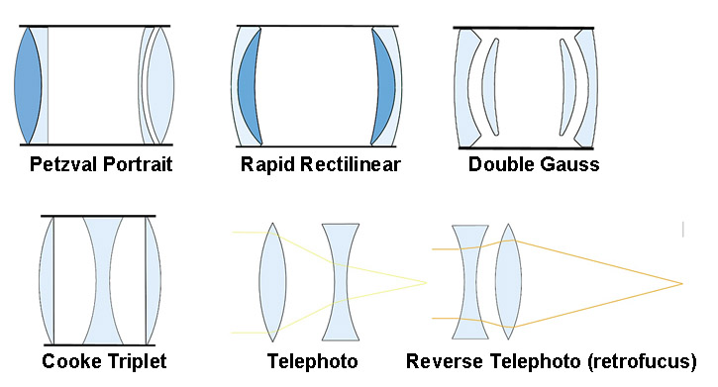

**Figure 1**: Common lens designs [1].

**I. Lens Parameters:**

One such parameter is focal length, which is the distance, typically measured in millimeters, between the lens's nodal point and the camera's sensor. For a given sensor size, this defines the angular field of view and magnification.

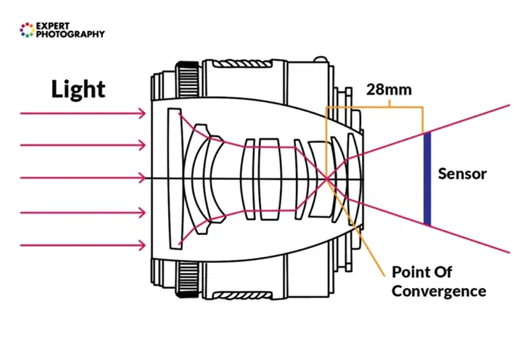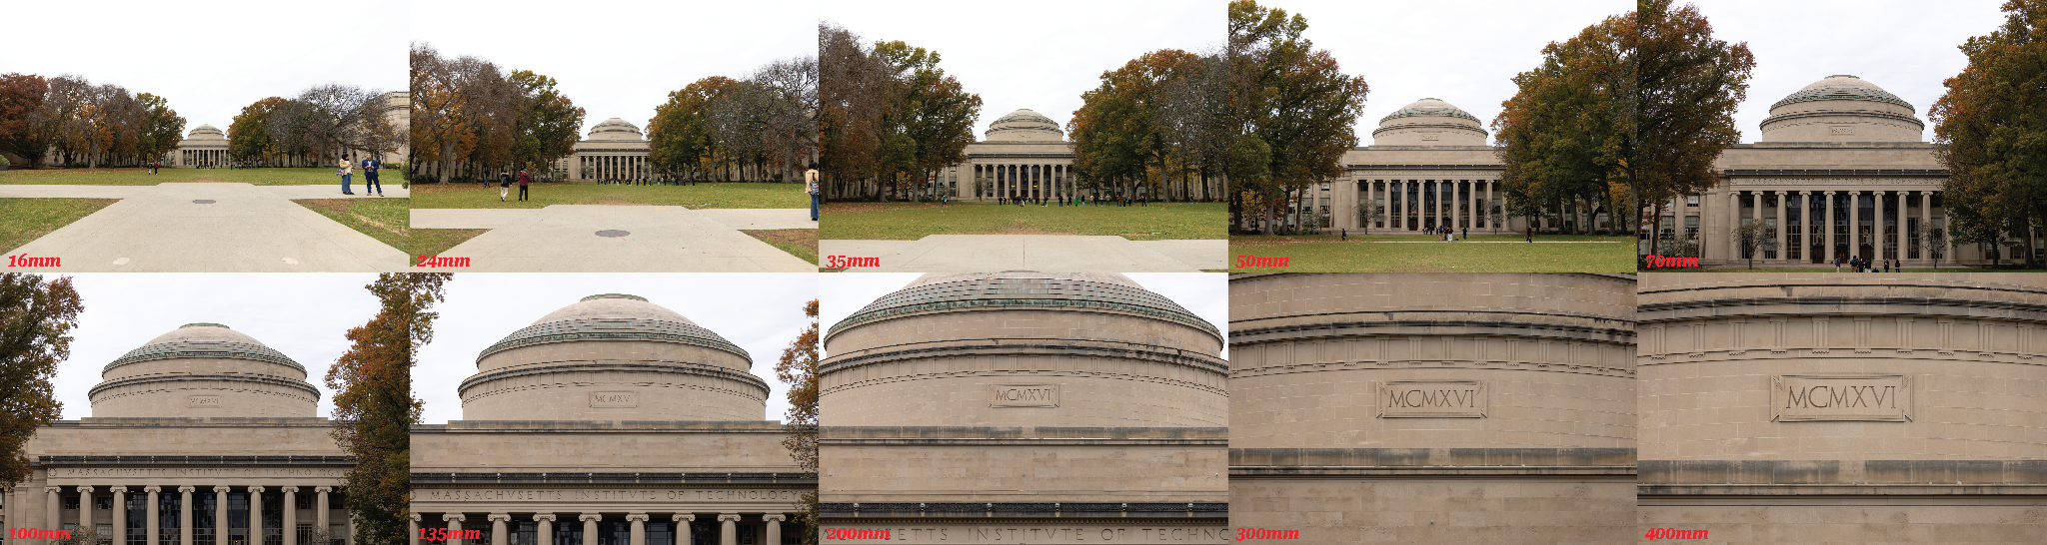

**Figure 2:** On the left, the 28mm is the focal length [2]. On the right is a visualization of this [3]. Lower focal lengths correspond to larger angle of view and lower magnification.

f/#, pronounced f-number or f-ratio, refers to the ratio between a lens’ focal length and its maximum aperture. Aperture, like the pupil of an eye, is the opening of a camera lens that dictates how much light enters. This ratio is important because it governs a lens’ ability to gather light. For the same maximum aperture, a lens with a focal length of 50mm will gather twice as much light as a lens with a focal length of 100mm, and images captured using the longer lens will be half as bright. Therefore, the quantity that needs to be maintained is the ratio between the focal length and the maximum aperture. This way, lenses that are specified to have an f/# of f/2.8, for example, will expose an image equally.

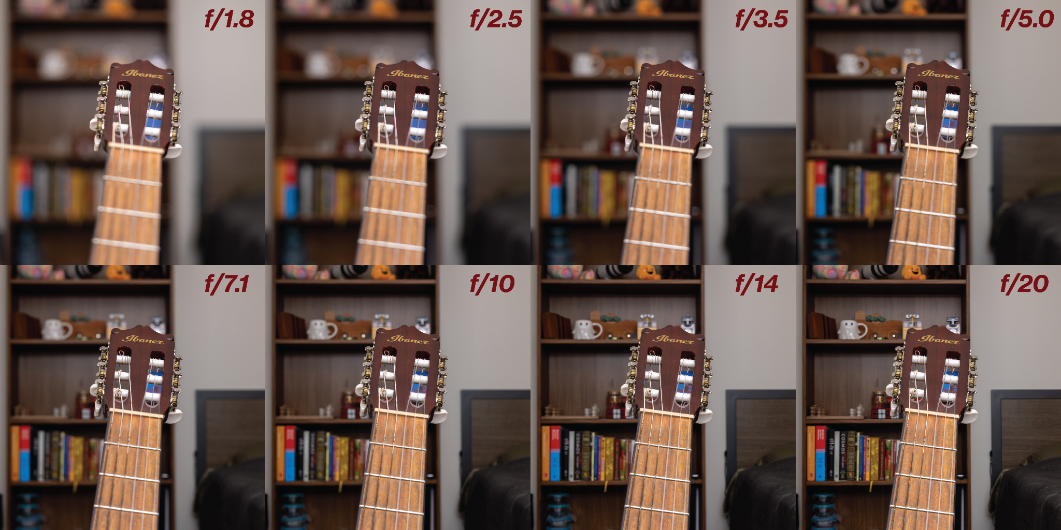

**Figure 3:** A smaller f-number, like f/1.8, is a wider aperture that lets in more light and has a shallow depth of field. A larger aperture, like f/20, is a smaller aperture that lets in less light and has a deep depth of field, allowing more objects to be in focus.

The ½ diagonal dimension of the camera sensor is a final parameter. This is noted in inches, however it does not physically correlate to the diagonal of the sensor. Given a sensor size, the diagonal can be calculated with easily available equations [5]:

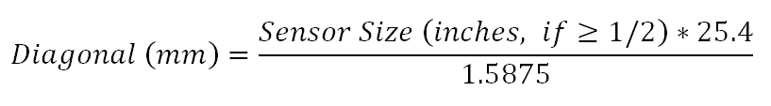 (1)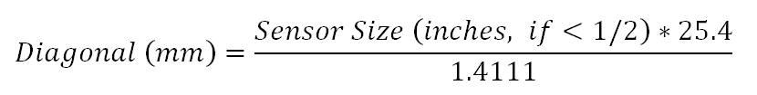 (2)

**II. Lens Performance:**

Vignetting is the darkening of corners in an image. Distortions are when straight lines in the scene do not remain straight in the image; it’s a lack of rectilinearity, aka warping. Field curvature is when focus lies on a curved plane instead of a flat one. This causes either the center of an image to be blurry while the edges are in focus, or vice versa. All are optical aberrations that decrease the value of a lens design.

**Project Goal**: Create a model that, given a desired camera’s focal length, F/#, and HFOV, produces lens designs. The top 5 highest performing designs, judged by minimized vignetting, distortions, and field curvature, will be displayed.

**Progress:** The main software in use is Zemax OpticStudio. We found a dataset of 1043 existing lens designs crowd sourced from patents or individual lens designer’s creations. The dataset comes with a spreadsheet that labels each design’s focal length, f/#, and ½ diagonal sensor size. Using the ZOS-API in Zemax, we coded an interactive extension in MATLAB that saves the Lens Data onto a CSV file, and another routine that automatically prompts Zemax’s Analyze tab to run a Relative Illumination, Field Curve/Distortion, Longitudinal Aberration, and RMS vs. Field analyses which are also saved onto CSV files.

The main software in use is Zemax OpticStudio. We found a dataset with 1043 existing lens designs, described not only by the focal length, F/#, and HFOV, but also by [insert]. A script was written to import this data into Zemax [i don’t actually know what you did]. Zemax was used to calculate the vignetting, distortions, and field curvature of these existing lens designs. The data/images of these designs, as well as the associated performance parameters, were all exported and used to train a CNN/DNN.

* Dataset and/or simulation software
* Visualization of input and output distributions and samples
* Preliminary ML/optimization results

**Next steps:** Right now our model produces many lens designs. We’d like to incorporate a performance evaluation to choose the top five based on vignetting, distortions, and field curvature, and need to decide how to weigh them (this could also be the user’s choice!)

**Works Cited**

[1] [https://www.google.com/url?sa=i&url=https%3A%2F%2Fwww.lensrentals.com%2Fblog%2F2011%2F08%2Flens-geneology-part-1%2F%3Fsrsltid%3DAfmBOoqQ422cf9Z5RyrZaGCWSWTljZ8TeqgEniuyM03IxU3aP-aa3CO-&psig=AOvVaw1Kojk1uwT97eUve5gLsy5G&ust=1762391048779000&source=images&cd=vfe&opi=89978449&ved=0CAMQjB1qFwoTCIj3-LTo2ZADFQAAAAAdAAAAABAE](https://www.lensrentals.com/blog/2011/08/lens-geneology-part-1/?srsltid=AfmBOoqQ422cf9Z5RyrZaGCWSWTljZ8TeqgEniuyM03IxU3aP-aa3CO-)

[2] [https://www.google.com/url?sa=i&url=https%3A%2F%2Fexpertphotography.com%2Funderstand-focal-length-4-easy-steps%2F&psig=AOvVaw1SuH9Nk3AXDFUxjJyjCW4I&ust=1762392734922000&source=images&cd=vfe&opi=89978449&ved=0CBoQ3YkBahcKEwjA-Obi7tmQAxUAAAAAHQAAAAAQLA](https://expertphotography.com/understand-focal-length-4-easy-steps/)

[3] <https://www.google.com/url?sa=i&url=https%3A%2F%2Fcolesclassroom.com%2Ffocal-length-basics-every-photographer%2F&psig=AOvVaw1SuH9Nk3AXDFUxjJyjCW4I&ust=1762392734922000&source=images&cd=vfe&opi=89978449&ved=0CBoQ3YkBahcKEwjA-Obi7tmQAxUAAAAAHQAAAAAQBA>

[4] <https://www.google.com/url?sa=i&url=https%3A%2F%2Fwww.sgadgoi.com%2Fc%2Fcamera-lens-f-meaning-ebe1754-02-26241183-2-8%2F&psig=AOvVaw19iflm9Tq9UPDRDqfSMruD&ust=1762395482461000&source=images&cd=vfe&opi=89978449&ved=0CBYQjRxqFwoTCOCbgoH52ZADFQAAAAAdAAAAABAL>

[5] <https://www.tucsen.com/learning/demystifying-specifications-sensor-size/> 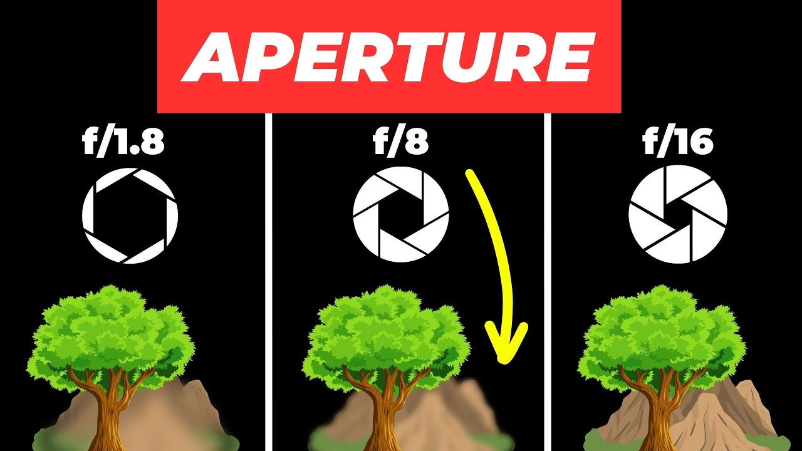[4]